Adventure Works Executive Summary

Introduction:
Adventure Works executive summary, entrusted with the significant responsibility of transforming the sales and customer data of Adventure Works into a series of compelling, actionable Microsoft Power BI visuals. The exercise aimed to provide the company's executive team with insightful and targeted information that could drive strategic decision-making at the highest level.
Key Insights:
- Create a variety of visualizations, including a table, column chart, line chart, and Key Performance Indicators (KPIs), to represent complex sales and customer data in a digestible format.
- Customize these visuals by setting specific colors and adding tooltips, enhancing the user experience and accessibility of the data.
- Implement forecasting functionalities on the line chart, empowering the executives to anticipate future sales trends and take proactive measures.
- Integrate a Q&A visual into the report, enabling the executive team to query the data directly and receive timely insights.

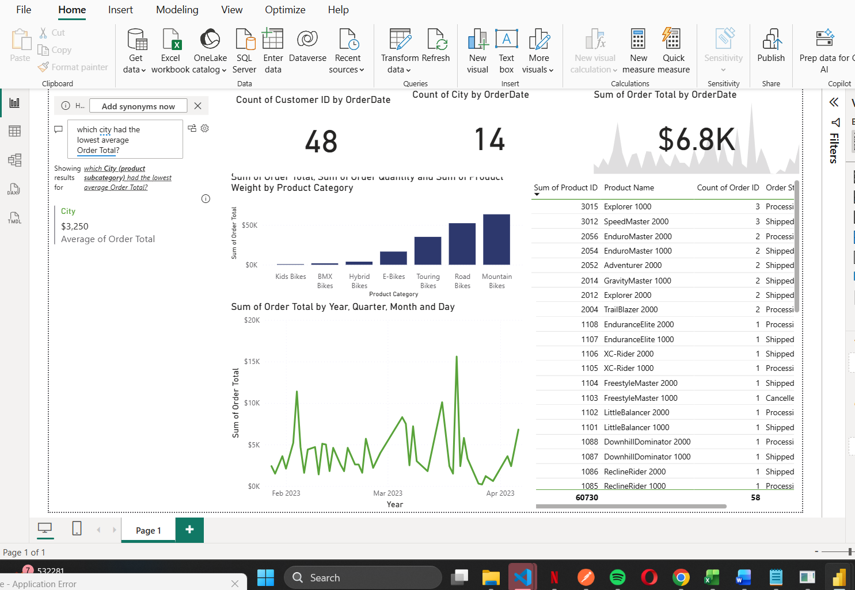

Conclusion:

In doing so,empowered decision-makers to act swiftly, strategically, and substantively. Every visualization and every KPI set could be the butterfly effect that drives a revolution. Now, out there and turn those numbers into narratives that can drive business outcomes.

